**In class Programming Assignment - 9**

**GitHub Link:** <https://github.com/Viditha2277/CS-5720/tree/main/Assignment%209>

**Problem 1:** Basics of LSTM, Types of RNN, Sentiment Analysis on the Twitter data set

**Solution:**

1. Saving the model and using the saved model to predict on new text data.

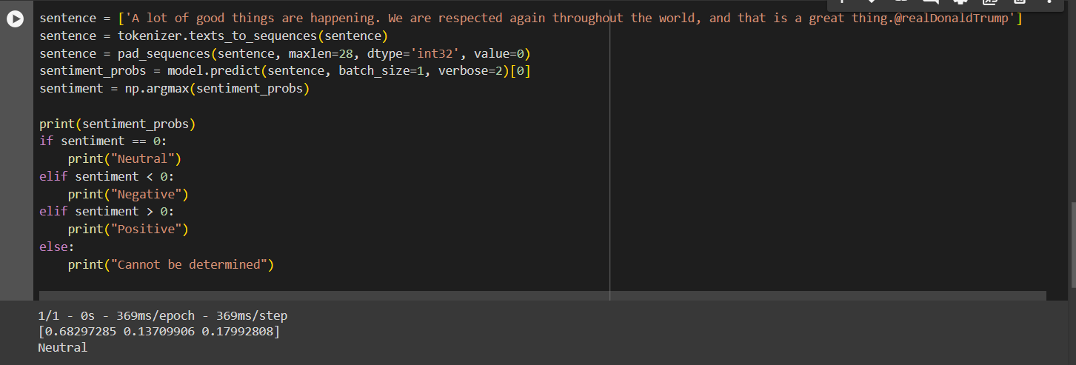

1. Applying GridSearchCV on the source code provided in the class.



